Министерство науки и высшего образования Российской Федерации
ФЕДЕРАЛЬНОЕ ГОСУДАРСТВЕННОЕ АВТОНОМНОЕ ОБРАЗОВАТЕЛЬНОЕ УЧРЕЖДЕНИЕ ВЫСШЕГО ОБРАЗОВАНИЯ
НАЦИОНАЛЬНЫЙ ИССЛЕДОВАТЕЛЬСКИЙ УНИВЕРСИТЕТ ИТМО
(НИУ ИТМО)

Факультет программной инженерии и компьютерной техники
ОТЧЁТ
О ЛАБОРАТОРНОЙ РАБОТЕ №6
Администрирование систем и сетей
по теме:
Создание WLAN
Желаемая оценка: 3

Выполнили: студенты группы P3434
Р. Д. Баянов
Д. А. Кузнецов

Проверил:
преподаватель А. Н. Максимов

Санкт-Петербург 2025

СОДЕРЖАНИЕ
План работы 3
1 Ход работы 4
1.1 Настройка основных параметров устройства 4
1.2 Настройка параметров проводной сети 4
1.3 Настройка параметров точек доступа для выхода в сеть 6
1.4 Настройка параметров сервиса WLAN 8
ЗАКЛЮЧЕНИЕ 21

План работы
1. Настройка подключения к проводной сети.
2. Настройка точек доступа и перевод их в режим онлайн.
(1) Создание групп точек доступа и добавление точек доступа с одинаковой конфигурацией в одну группу для унифицированной настройки.
(2) Настройка системных параметров контроллера доступа, включая код страны и интерфейс-источник, используемый контроллером для связи с точками доступа.
(3) Настройка режима аутентификации AP и импорт AP для выхода точек доступа в сеть.
3. Настройка параметров сервисов WLAN и передача конфигурации точкам доступа, чтобы обеспечить доступ STA к WLAN.
- Ход работы

Настройка основных параметров устройства

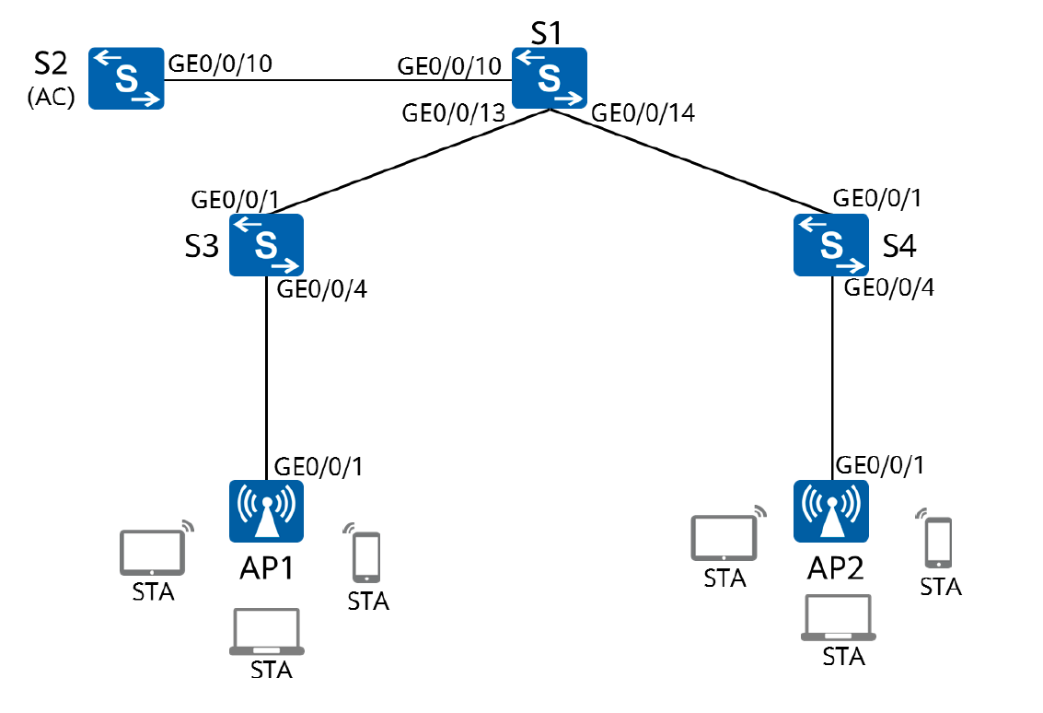

POE подключен автоматически

Настройка параметров проводной сети

Настройка VLAN
[S1]vlan batch 100 101
[S1]interface GigabitEthernet0/0/2
[S1-GigabitEthernet0/0/2]port link-type trunk
[S1-GigabitEthernet0/0/2]port trunk allow-pass vlan 100 101
[S1-GigabitEthernet0/0/2]quit
[S1]interface GigabitEthernet0/0/3
[S1-GigabitEthernet0/0/3]port link-type trunk
[S1-GigabitEthernet0/0/3]port trunk allow-pass vlan 100 101
[S1-GigabitEthernet0/0/3]quit
[S1]interface GigabitEthernet0/0/1
[S1-GigabitEthernet0/0/1]port link-type trunk
[S1-GigabitEthernet0/0/1]port trunk allow-pass vlan 100 101

[AC]vlan batch 100 101
Info: This operation may take a few seconds. Please wait for a moment...done.
[AC]interface GigabitEthernet 0/0/1
[AC-GigabitEthernet0/0/1]port link-type trunk
[AC-GigabitEthernet0/0/1]port trunk allow-pass vlan 100 101
[AC-GigabitEthernet0/0/1]quit

[S3]vlan batch 100 101
[S3]interface GigabitEthernet 0/0/2
[S3-GigabitEthernet0/0/2]port link-type trunk
[S3-GigabitEthernet0/0/2]port trunk allow-pass vlan 100 101
[S3-GigabitEthernet0/0/2]quit
[S3]interface GigabitEthernet 0/0/1
[S3-GigabitEthernet0/0/1]port link-type trunk
[S3-GigabitEthernet0/0/1]port trunk pvid vlan 100
[S3-GigabitEthernet0/0/1]port trunk allow-pass vlan 100 101
[S3-GigabitEthernet0/0/1]quit

[S4]interface GigabitEthernet0/0/3
[S4-GigabitEthernet0/0/3]port link-type trunk
[S4-GigabitEthernet0/0/3]port trunk allow-pass vlan 100 to 101
[S4-GigabitEthernet0/0/3]quit
[S4]interface GigabitEthernet0/0/1
[S4-GigabitEthernet0/0/1]port link-type trunk
[S4-GigabitEthernet0/0/1]port trunk pvid vlan 100
[S4-GigabitEthernet0/0/1]port trunk allow-pass vlan 100 to 101
[S4-GigabitEthernet0/0/1]quit

Настройка IP адресов интерфейсов
[S1]interface Vlanif 101
[S1-Vlanif101]ip address 192.168.101.254 24
[S1-Vlanif101]quit
[S1]interface LoopBack 0
[S1-LoopBack0]ip address 10.0.1.1 32
[S1-LoopBack0]interface Vlanif 100
[S1-Vlanif100]ip address 192.168.100.254 24

Настройка DHCP
[AC]interface Vlanif 100
[AC-Vlanif100]ip address 192.168.100.254 24

[S1]dhcp enable
[S1]ip pool sta
[S1-ip-pool-sta]network 192.168.101.0 mask 24
[S1-ip-pool-sta]gateway-list 192.168.101.254
[S1-ip-pool-sta]
[S1-ip-pool-sta]quit
[S1]interface Vlanif 101
[S1-Vlanif101]dhcp select global
[S1-Vlanif101]quit

[AC]dhcp enable
[AC]ip pool ap
Info: It is successful to create an IP address pool.
[AC-ip-pool-ap]network 192.168.100.254 mask 24
[AC-ip-pool-ap]gateway-list 192.168.100.254
[AC-ip-pool-ap]quit
[AC]interface Vlanif 100
[AC-Vlanif100]dhcp select global
[AC-Vlanif100]quit

Настройка параметров точек доступа для выхода в сеть

[AC]wlan
[AC-wlan-view]ap-group name ap-group1
[AC-wlan-ap-group-ap-group1]quit

Создаем профиль регулирующего домена и настраиваем код страны AC в профиле
[AC-wlan-view]regulatory-domain-profile name default

Настройка кода страны
[AC-wlan-regulate-domain-default]country-code cn

[AC]wlan
[AC-wlan-view]ap-group name ap-group1
[AC-wlan-ap-group-ap-group1]regulatory-domain-profile default

Настройка интерфейса
[AC-Vlanif100]capwap source interface Vlanif 100

Настройка аутентификации точек доступа
[AC-Vlanif100]capwap source interface Vlanif 100

Настройка аутентификации точек доступа
[AC]wlan
[AC-wlan-view]ap auth-mode mac-auth

Настройка MAC адресов для аутентификации
Узнаем MAC на AP1
[Huawei]display interface GigabitEthernet 0/0/1

00e0-fcc1-1570

Узнаем MAC на AP2
00e0-fcc1-1570

Добавляем их в AC
[AC-wlan-view]ap-id 0 ap-mac 00e0-fcc1-1570
[AC-wlan-ap-0]ap-id 1 ap-mac 00e0-fc71-3a80

Настройка группы AP в AC
[AC-wlan-view]ap-id 0
[AC-wlan-ap-0]ap-name ap1
[AC-wlan-ap-0]ap-group ap-group1

[AC-wlan-view]ap-id 0
[AC-wlan-ap-0]ap-name ap1
[AC-wlan-ap-0]ap-group ap-group1

Вывод информации о текущей WLAN на AC
[AC]wlan
[AC-wlan-view]display ap all
Info: This operation may take a few seconds. Please wait for a moment.done.
Total AP information:
nor : normal [2]
--------------------------------------------------------------------------------
--------------
ID MAC Name Group IP Type State STA Upt
ime
--------------------------------------------------------------------------------
--------------
0 00e0-fcc1-1570 ap1 ap-group1 192.168.100.207 AP6050DN nor 0 3M:
23S
1 00e0-fc71-3a80 ap2 ap-group1 192.168.100.217 AP6050DN nor 0 1M:
34S
--------------------------------------------------------------------------------
--------------
Total: 2

Настройка параметров сервиса WLAN

[AC-wlan-view]security-profile name HCIA-WLAN
[AC-wlan-sec-prof-HCIA-WLAN]security wpa-wpa2 psk pass-phrase HCIA-Datacom aes
[AC-wlan-sec-prof-HCIA-WLAN]quit

Создание профиля SSID HCIA-WLAN
[AC-wlan-view]ssid-profile name HCIA-WLAN
[AC-wlan-ssid-prof-HCIA-WLAN]ssid HCIA-WLAN
[AC-wlan-ssid-prof-HCIA-WLAN]quit

Создание профиля VAP HCIA-WLAN, применение профиля безопасности
[AC]wlan
[AC-wlan-view]vap-profile name HCIA-WLAN

Настройка режима передачи
[AC-wlan-vap-prof-HCIA-WLAN]forward-mode direct-forward

Настройка сервисной VLAN
[AC-wlan-vap-prof-HCIA-WLAN]service-vlan vlan-id 101

Применение профилей
[AC-wlan-vap-prof-HCIA-WLAN]security-profile HCIA-WLAN
[AC-wlan-vap-prof-HCIA-WLAN]ssid-profile HCIA-WLAN
[AC-wlan-vap-prof-HCIA-WLAN]quit

Привязка профиля AP к группе AP и примение конфигурации профиля VAP HCIA-WLAN к радиомодулю 0 и радиомодулю 1 точек доступа в группе AP
[AC-wlan-view]ap-group name ap-group1
[AC-wlan-ap-group-ap-group1]vap-profile HCIA-WLAN wlan 1 radio all

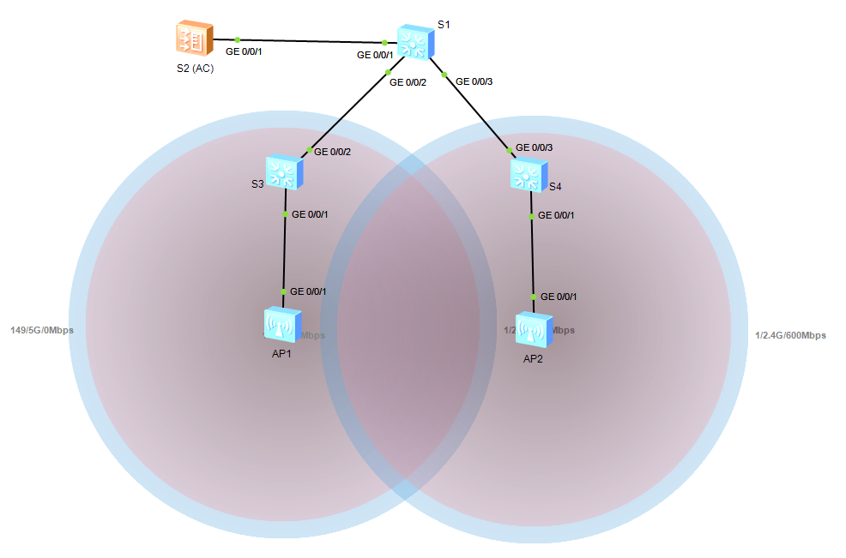

Проверка
Подключение STA
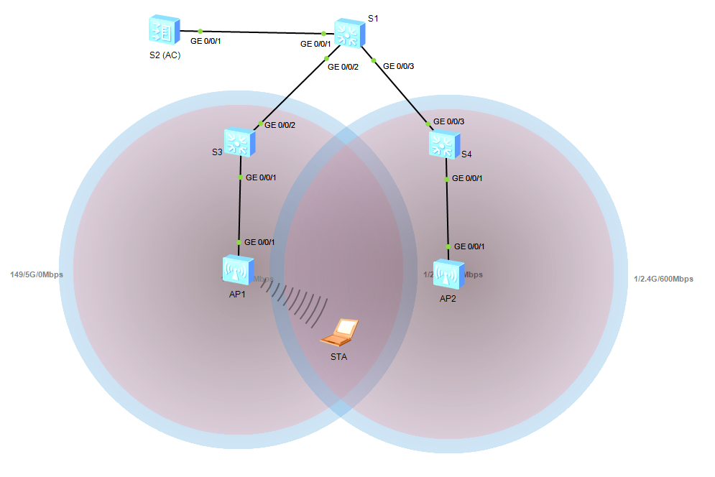

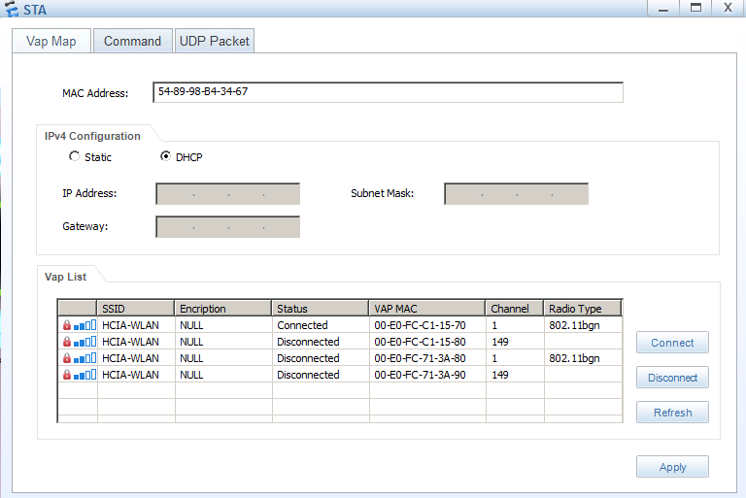

Выданный IP
STA>ipconfig

Link local IPv6 address...........: ::
IPv6 address......................: :: / 128
IPv6 gateway......................: ::
IPv4 address......................: 192.168.101.253
Subnet mask.......................: 255.255.255.0
Gateway...........................: 192.168.101.254
Physical address..................: 54-89-98-B4-34-67
DNS server........................:

STA>

Ping S1 Loopback 0
STA>ping 10.0.1.1

Ping 10.0.1.1: 32 data bytes, Press Ctrl_C to break
From 10.0.1.1: bytes=32 seq=1 ttl=255 time=203 ms
From 10.0.1.1: bytes=32 seq=2 ttl=255 time=203 ms
From 10.0.1.1: bytes=32 seq=3 ttl=255 time=203 ms
From 10.0.1.1: bytes=32 seq=4 ttl=255 time=204 ms
From 10.0.1.1: bytes=32 seq=5 ttl=255 time=203 ms

--- 10.0.1.1 ping statistics ---
5 packet(s) transmitted
5 packet(s) received
0.00% packet loss
round-trip min/avg/max = 203/203/204 ms

STA>

Проверка информации об STA на AC
[AC]display station all
Rf/WLAN: Radio ID/WLAN ID
Rx/Tx: link receive rate/link transmit rate(Mbps)
--------------------------------------------------------------------------------
----------------------
STA MAC AP ID Ap name Rf/WLAN Band Type Rx/Tx RSSI VLAN IP a
ddress SSID
--------------------------------------------------------------------------------
----------------------
5489-98b4-3467 0 ap1 0/1 2.4G - -/- - 101 192.
168.101.253 HCIA-WLAN
--------------------------------------------------------------------------------
----------------------
Total: 1 2.4G: 1 5G: 0
[AC]

Использованное оборудование
<S1>display current-configuration
#
sysname S1
#
vlan batch 100 to 101
#
cluster enable
ntdp enable
ndp enable
#
drop illegal-mac alarm
#
dhcp enable
#
diffserv domain default
#
drop-profile default
#
ip pool sta
gateway-list 192.168.101.254
network 192.168.101.0 mask 255.255.255.0
#
aaa
authentication-scheme default
authorization-scheme default
accounting-scheme default
domain default
domain default_admin
local-user admin password simple admin
local-user admin service-type http
#
interface Vlanif1
#
interface Vlanif100
ip address 192.168.100.254 255.255.255.0
#
interface Vlanif101
ip address 192.168.101.254 255.255.255.0
dhcp select global
#
interface MEth0/0/1
#
interface GigabitEthernet0/0/1
port link-type trunk
port trunk allow-pass vlan 100 to 101
#
interface GigabitEthernet0/0/2
port link-type trunk
port trunk allow-pass vlan 100 to 101
#
interface GigabitEthernet0/0/3
port link-type trunk
port trunk allow-pass vlan 100 to 101
#
interface GigabitEthernet0/0/4
#
interface GigabitEthernet0/0/5
#
interface GigabitEthernet0/0/6
#
interface GigabitEthernet0/0/7
#
interface GigabitEthernet0/0/8
#
interface GigabitEthernet0/0/9
#
interface GigabitEthernet0/0/10
#
interface GigabitEthernet0/0/11
#
interface GigabitEthernet0/0/12
#
interface GigabitEthernet0/0/13
#
interface GigabitEthernet0/0/14
#
interface GigabitEthernet0/0/15
#
interface GigabitEthernet0/0/16
#
interface GigabitEthernet0/0/17
#
interface GigabitEthernet0/0/18
#
interface GigabitEthernet0/0/19
#
interface GigabitEthernet0/0/20
#
interface GigabitEthernet0/0/21
#
interface GigabitEthernet0/0/22
#
interface GigabitEthernet0/0/23
#
interface GigabitEthernet0/0/24
#
interface NULL0
#
interface LoopBack0
ip address 10.0.1.1 255.255.255.255
#
user-interface con 0
user-interface vty 0 4
#
return

<AC>display current-configuration
#
sysname AC
#
undo http secure-server enable
#
set memory-usage threshold 0
#
ssl renegotiation-rate 1
#
vlan batch 100 to 101
#
authentication-profile name default_authen_profile
authentication-profile name dot1x_authen_profile
authentication-profile name mac_authen_profile
authentication-profile name portal_authen_profile
authentication-profile name macportal_authen_profile
#
dhcp enable
#
diffserv domain default
#
radius-server template default
#
pki realm default
rsa local-key-pair default
enrollment self-signed
#
ike proposal default
encryption-algorithm aes-256
dh group14
authentication-algorithm sha2-256
authentication-method pre-share
integrity-algorithm hmac-sha2-256
prf hmac-sha2-256
#
free-rule-template name default_free_rule
#
portal-access-profile name portal_access_profile
#
ip pool ap
gateway-list 192.168.100.254
network 192.168.100.0 mask 255.255.255.0
#
aaa
authentication-scheme default
authentication-scheme radius
authentication-mode radius
authorization-scheme default
accounting-scheme default
domain default
authentication-scheme radius
radius-server default
domain default_admin
authentication-scheme default
local-user admin password irreversible-cipher $1a$3uLL'kWye#$a^w|:yk,TLLbg'&uhy
}6!mBD6vw'4(p-hPRifI45$
local-user admin service-type http
#
interface Vlanif100
ip address 192.168.100.254 255.255.255.0
dhcp select global
#
interface GigabitEthernet0/0/1
port link-type trunk
port trunk allow-pass vlan 100 to 101
#
interface GigabitEthernet0/0/2
#
interface GigabitEthernet0/0/3
#
interface GigabitEthernet0/0/4
#
interface GigabitEthernet0/0/5
#
interface GigabitEthernet0/0/6
#
interface GigabitEthernet0/0/7
undo negotiation auto
duplex half
#
interface GigabitEthernet0/0/8
undo negotiation auto
duplex half
#
interface NULL0
#
snmp-agent local-engineid 800007DB03000000000000
snmp-agent
#
ssh server secure-algorithms cipher aes256_ctr aes128_ctr
ssh server key-exchange dh_group14_sha1
ssh client secure-algorithms cipher aes256_ctr aes128_ctr
ssh client secure-algorithms hmac sha2_256
ssh client key-exchange dh_group14_sha1
#
capwap source interface vlanif100
#
user-interface con 0
user-interface vty 0 4
protocol inbound all
user-interface vty 16 20
protocol inbound all
#
wlan
traffic-profile name default
security-profile name default
security-profile name HCIA-WLAN
security wpa-wpa2 psk pass-phrase %^%#l$I9VJzSt;.@/w;WacY2[Lj3PM`Nh~k[L\'FqoH;
%^%# aes
security-profile name default-wds
security-profile name default-mesh
ssid-profile name default
ssid-profile name HCIA-WLAN
ssid HCIA-WLAN
vap-profile name default
vap-profile name HCIA-WLAN
service-vlan vlan-id 101
ssid-profile HCIA-WLAN
security-profile HCIA-WLAN
wds-profile name default
mesh-handover-profile name default
mesh-profile name default
regulatory-domain-profile name default
air-scan-profile name default
rrm-profile name default
radio-2g-profile name default
radio-5g-profile name default
wids-spoof-profile name default
wids-profile name default
wireless-access-specification
ap-system-profile name default
port-link-profile name default
wired-port-profile name default
serial-profile name preset-enjoyor-toeap
ap-group name default
ap-group name ap-group1
radio 0
vap-profile HCIA-WLAN wlan 1
radio 1
vap-profile HCIA-WLAN wlan 1
radio 2
vap-profile HCIA-WLAN wlan 1
ap-id 0 type-id 56 ap-mac 00e0-fcc1-1570 ap-sn 21023544831076312476
ap-name ap1
ap-group ap-group1
ap-id 1 type-id 56 ap-mac 00e0-fc71-3a80 ap-sn 21023544831062687B1F
ap-name ap2
ap-group ap-group1
provision-ap
#
dot1x-access-profile name dot1x_access_profile
#
mac-access-profile name mac_access_profile
#
return
<AC>

<S3>display current-configuration
#
sysname S3
#
vlan batch 100 to 101
#
cluster enable
ntdp enable
ndp enable
#
drop illegal-mac alarm
#
diffserv domain default
#
drop-profile default
#
aaa
authentication-scheme default
authorization-scheme default
accounting-scheme default
domain default
domain default_admin
local-user admin password simple admin
local-user admin service-type http
#
interface Vlanif1
#
interface MEth0/0/1
#
interface GigabitEthernet0/0/1
port link-type trunk
port trunk pvid vlan 100
port trunk allow-pass vlan 100 to 101
#
interface GigabitEthernet0/0/2
port link-type trunk
port trunk allow-pass vlan 100 to 101
#
interface GigabitEthernet0/0/3
#
interface GigabitEthernet0/0/4
#
interface GigabitEthernet0/0/5
#
interface GigabitEthernet0/0/6
#
interface GigabitEthernet0/0/7
#
interface GigabitEthernet0/0/8
#
interface GigabitEthernet0/0/9
#
interface GigabitEthernet0/0/10
#
interface GigabitEthernet0/0/11
#
interface GigabitEthernet0/0/12
#
interface GigabitEthernet0/0/13
#
interface GigabitEthernet0/0/14
#
interface GigabitEthernet0/0/15
#
interface GigabitEthernet0/0/16
#
interface GigabitEthernet0/0/17
#
interface GigabitEthernet0/0/18
#
interface GigabitEthernet0/0/19
#
interface GigabitEthernet0/0/20
#
interface GigabitEthernet0/0/21
#
interface GigabitEthernet0/0/22
#
interface GigabitEthernet0/0/23
#
interface GigabitEthernet0/0/24
#
interface NULL0
#
user-interface con 0
user-interface vty 0 4
#
return

<S4>display current-configuration
#
sysname S4
#
vlan batch 100 to 101
#
cluster enable
ntdp enable
ndp enable
#
drop illegal-mac alarm
#
diffserv domain default
#
drop-profile default
#
aaa
authentication-scheme default
authorization-scheme default
accounting-scheme default
domain default
domain default_admin
local-user admin password simple admin
local-user admin service-type http
#
interface Vlanif1
#
interface MEth0/0/1
#
interface GigabitEthernet0/0/1
port link-type trunk
port trunk pvid vlan 100
port trunk allow-pass vlan 100 to 101
#
interface GigabitEthernet0/0/2
#
interface GigabitEthernet0/0/3
port link-type trunk
port trunk allow-pass vlan 100 to 101
#
interface GigabitEthernet0/0/4
#
interface GigabitEthernet0/0/5
#
interface GigabitEthernet0/0/6
#
interface GigabitEthernet0/0/7
#
interface GigabitEthernet0/0/8
#
interface GigabitEthernet0/0/9
#
interface GigabitEthernet0/0/10
#
interface GigabitEthernet0/0/11
#
interface GigabitEthernet0/0/12
#
interface GigabitEthernet0/0/13
#
interface GigabitEthernet0/0/14
#
interface GigabitEthernet0/0/15
#
interface GigabitEthernet0/0/16
#
interface GigabitEthernet0/0/17
#
interface GigabitEthernet0/0/18
#
interface GigabitEthernet0/0/19
#
interface GigabitEthernet0/0/20
#
interface GigabitEthernet0/0/21
#
interface GigabitEthernet0/0/22
#
interface GigabitEthernet0/0/23
#
interface GigabitEthernet0/0/24
#
interface NULL0
#
user-interface con 0
user-interface vty 0 4
#
return

ЗАКЛЮЧЕНИЕ
Цель работы достигнута.

